Project Design Phase-II Technology Stack (Architecture & Stack)

|  |  |
| --- | --- |
| Date | 18 December |
| Team ID | 591966 |
| Project Name | Movie Recommender System |
| Maximum Marks | 4 Marks |

Technical Architecture:

The Deliverable shall include the architectural diagram as below and the information as per the table1 & table 2

Example: Order processing during pandemics for offline mode

Reference: <https://developer.ibm.com/patterns/ai-powered-backend-system-for-order-processing-during-pandemics/>

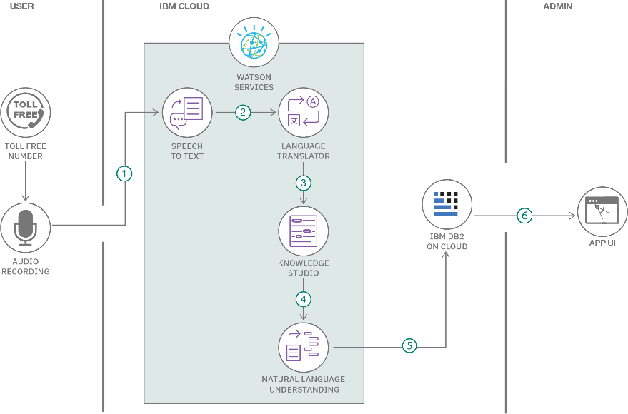

Table-1 : Components & Technologies:

|  |  |  |  |
| --- | --- | --- | --- |
| **S.No** | **Component** | **Description** | **Technology** |
| 1. | User Interface | The user can select a particular movie from the options of more than 5000 movies and get the desired movie they would love. | HTML, CSS |
| 2. | Application Logic-1 | The entire web application is supported by Streamlit python Library | Python |
| 3. | Application Logic-2 | Streamlit web page is hosted on a local host server | Streamlit |
| 4. | Database | Data files i.e pickle files and dict files are locally hosted on the system | Pycharm, Streamlit |
| 5. | External API-1 | TMDB ( The movie database ) API key is used to gather the names of the Movies based on their Movie_id. | TMDB API |
| 6. | External API-2 | TMDB API is used to gather the posters of the recommended movies from the TMDB server | TMDB API |
| 7. | Machine Learning Model | Content Based Filtering is the algorithm used as refining algorithm for recommending movies based on the content in the movie and recommending the similar movies. | Content Based Filtering |

Table-2: Application Characteristics:

|  |  |  |  |
| --- | --- | --- | --- |
| **S.No** | **Characteristics** | **Description** | **Technology** |
| 1. | Open-Source Frameworks | Streamlit | Streamlit |

|  |  |  |  |
| --- | --- | --- | --- |
| **S.No** | **Characteristics** | **Description** | **Technology** |
| 2. | Availability | It can be accessed by anyone inside the local network of the host with the ip address |  |

References:

<https://www.kaggle.com/datasets/tmdb/tmdb-movie-metadata>

<https://github.com/campusx-official/movie-recommender-system-tmdb-dataset>

<https://www.youtube.com/@campusx-official/videos>